# Distributed Task Scheduler System Design

## 1. System Overview

The distributed task scheduler is designed to allow clients to register both one-time and recurring tasks, ensuring their execution within 10 seconds of the scheduled time. The system aims to be highly available, durable, scalable, and cost-effective.

## 2. High-Level Architecture

The system consists of the following main components:

1. Client Interface
2. Task Manager
3. Task Scheduler
4. Worker Pool
5. Task Executor
6. Distributed Storage
7. Message Broker
8. Monitoring and Logging

### 2.1 Architecture Diagram

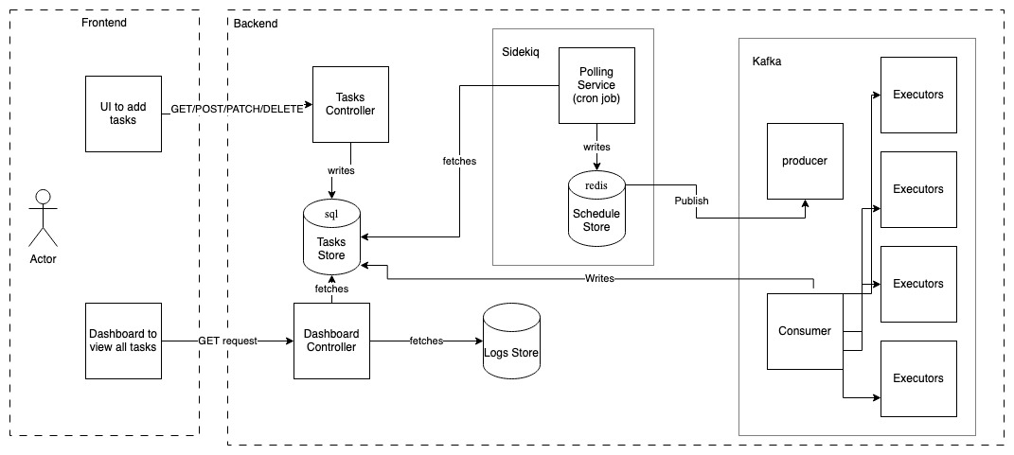

## 3. Component Details

### 3.1 Client Interface

* RESTful API for task registration, modification, and deletion
* WebSocket for real-time updates on task status

### 3.2 Task Manager

* Handles task CRUD operations
* Validates task input (e.g., cron syntax for recurring tasks)
* Interacts with Distributed Storage to persist task data

### 3.3 Task Scheduler

* Determines which tasks need to be executed in the near future
* Pushes tasks to the Message Queue for execution
* Handles rescheduling of recurring tasks

### 3.4 Worker Pool

* A pool of worker nodes that poll the Message Queue for tasks
* Dynamically scalable based on workload

### 3.6 Distributed Storage

* Stores task definitions, schedules, and execution history
* Provides high durability and consistency

### 3.7 Message Broker

* Decouples task scheduling from execution.
* Ensures tasks are not lost and can be retried if needed

### 3.8 Monitoring and Logging

* Tracks system health, performance metrics, and task execution
* Provides alerts for system issues or execution failures

## 4. Key Design Decisions and Tradeoffs

### 4.1 Distributed Architecture

**Decision**: Use a distributed architecture with multiple components.

**Rationale**: Enhances scalability, fault tolerance, and allows for independent scaling of components.

**Tradeoff**: Increased complexity in system design and management.

### 4.2 Message Queue for Task Distribution

**Decision**: Use a message queue to distribute tasks to workers.

**Rationale**: Provides decoupling, scalability, and ensures tasks are not lost even if workers fail.

**Tradeoff**: Introduces a small latency in task execution but greatly improves system reliability.

### 4.3 Cron Syntax for Recurring Tasks

**Decision**: Use cron syntax for defining recurring tasks.

**Rationale**: Widely understood, flexible, and can represent complex schedules.

**Tradeoff**: May be complex for some users; might require additional UI support for creating cron expressions.

### 4.4 Eventual Consistency for Task Status

**Decision**: Use eventual consistency for updating task status across the system.

**Rationale**: Allows for better performance and scalability.

**Tradeoff**: There might be a slight delay in reflecting task status updates in the client interface.

## 5. Scalability Considerations

### 5.1 Horizontal Scaling

* The Worker Pool can be scaled horizontally to handle increased task execution load.
* Multiple instances of Task Scheduler can be deployed to handle a growing number of scheduled tasks.

### 5.2 Database Sharding

* As the number of tasks grows, the Distributed Storage can be sharded based on task ID or scheduled execution time.

### 5.3 Caching Layer

* Implement a caching layer (e.g., Redis) to reduce database load for frequently accessed task data.

## 6. Handling Scale

### 6.1 Scaling Up (hundreds to thousands of tasks)

* Increase the number of worker nodes in the Worker Pool.
* Scale up the Message Queue to handle higher throughput.
* Implement read replicas for Distributed Storage to handle increased read load.

### 6.2 Scaling Up (thousands to millions of tasks)

* Implement database sharding in Distributed Storage.
* Use multiple Task Scheduler instances, each responsible for a subset of tasks.
* Implement a distributed caching layer to reduce database load.
* Consider using a distributed coordination service (e.g., Apache ZooKeeper) for leader election and task distribution among Task Scheduler instances.

## 7. Potential Bottlenecks and Solutions

### 7.1 Task Scheduler

**Bottleneck**: As the number of tasks grows, a single Task Scheduler may struggle to keep up.

**Solution**: Implement partitioning of tasks across multiple Task Scheduler instances, each responsible for a subset of tasks.

### 7.2 Database Write Operations

**Bottleneck**: High write load on the database for task updates and logging.

**Solution**: Implement write-behind caching and batch updates to reduce database write operations.

### 7.3 Network Bandwidth

**Bottleneck**: As the system scales, network bandwidth may become a limiting factor.

**Solution**: Implement data compression, use CDNs for static content, and optimize API payloads.

## 8. Cost-Effectiveness Strategies

1. Use auto-scaling for the Worker Pool to match resources with workload.
2. Implement task batching to reduce the number of database operations.
3. Use spot instances for non-critical worker nodes to reduce compute costs.
4. Implement data lifecycle management in Distributed Storage to archive or delete old task data.

## 9. Monitoring and Alerting

1. Implement comprehensive logging across all components.
2. Set up alerts for abnormal patterns, such as high task execution latency or increased error rates.
3. Use distributed tracing to identify performance bottlenecks across components.

## Conclusion

This distributed task scheduler design provides a scalable, reliable, and flexible solution for handling both one-time and recurring tasks. By leveraging distributed systems principles and cloud-native technologies, the system can scale from hundreds to millions of tasks while maintaining high availability and durability. Regular monitoring, optimization, and addressing of potential bottlenecks will be crucial for long-term success and cost-effectiveness of the system.